1  A | 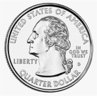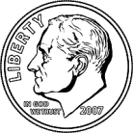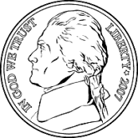
B
2
A
B
3
A
B
4
A
B

5
A
B
6
A
B
7
A
B
8
A
B

9
A
B
10
A
B

1  A |  | 67¢
B |  | 61¢
2  A |  | 86¢
B |  | 64¢
3  A |  | 50¢
B |  | 33¢
4  A |  | 88¢
B |  | $1.29

5  A |  | 93¢
B |  | 95¢
6  A |  | $1.00
B |  | 95¢
7  A |  | $1.25
B |  | $1.13
8  A |  | 91¢
B |  | 89¢

9  A |  | $1.32
B |  | $1.32
10  A |  | $1.59
B |  | $1.62

