1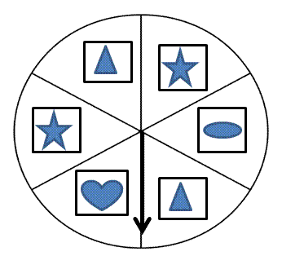 | 2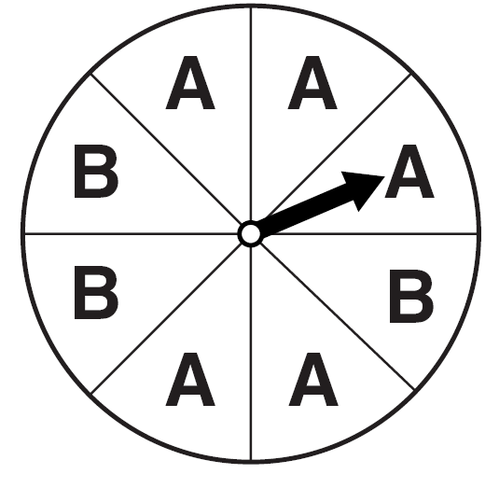 | 3 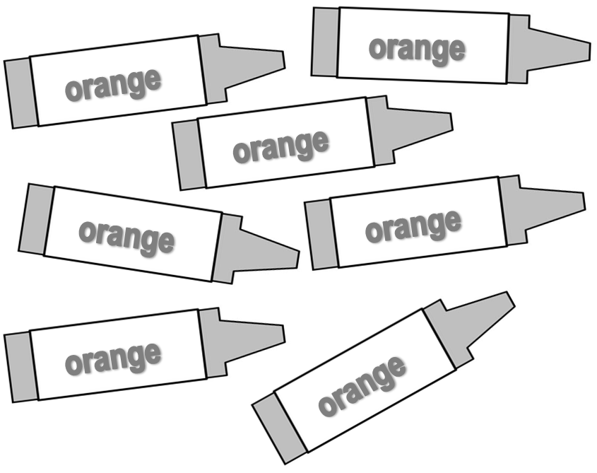
The spinner will land on a heart. | The spinner will land on the letter C. | You reach in without looking and pick an orange crayon.
4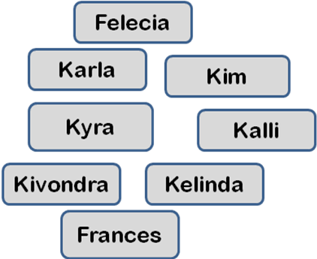 | 5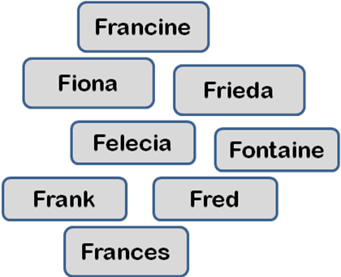 | 6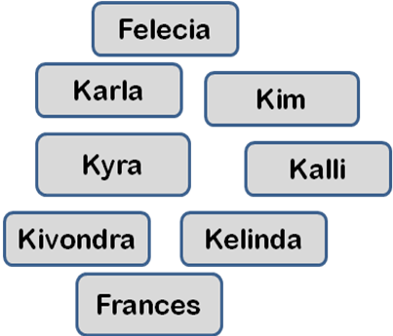
You reach in without looking and pick a name that begins with the letter F. | You reach in without looking and pick a name that begins with the letter F. | You reach in without looking and pick a name that begins with the letter K.
7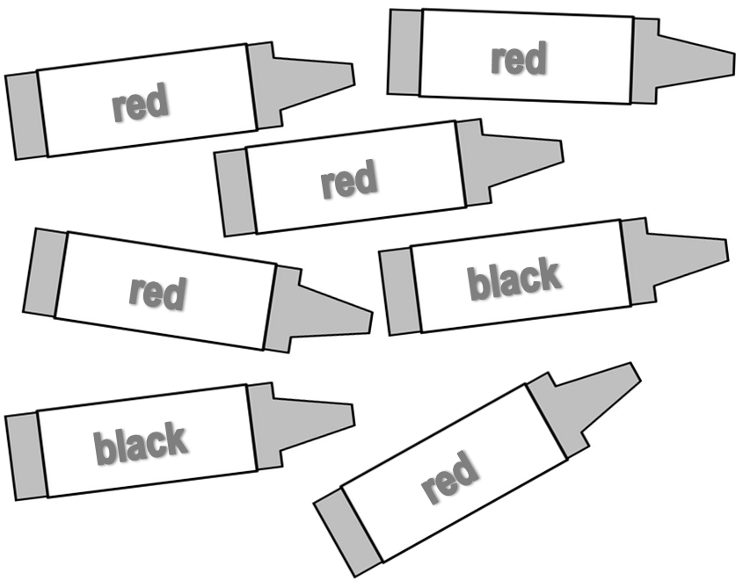 | 8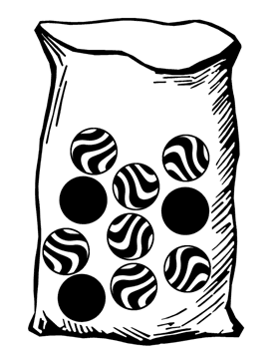 | 9
You reach in without looking and pick a black crayon. | You reach in without looking and pick a white marble. | You reach in without looking and pick a blue crayon.
  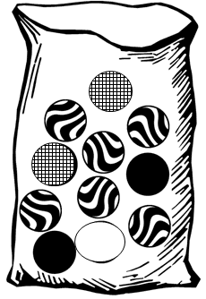 10 | 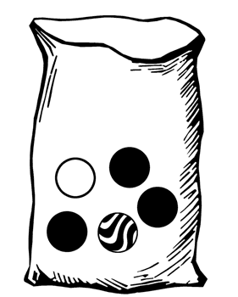 11 | 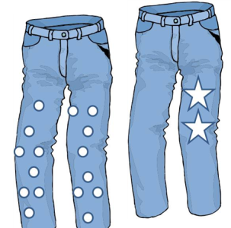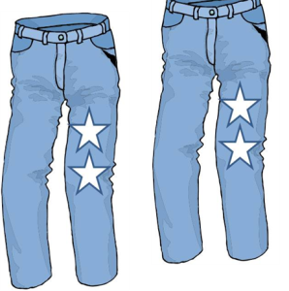  12
You reach in without looking and pick a swirled marble. | You reach in without looking and pick a black marble. | You reach in your closet without looking and pick out jeans with stars.

Likely, but not certain   | CERTAIN  
Unlikely, but not impossible | IMPOSSIBLE  
Directions:
Cut the cards on pages 1 and 2 so that the picture and probability question remain attached. A set of cards includes the 12 probability cards and the four category cards shown above.
Give each pair or group of students a set of cards. They will sort the cards into the four categories shown above. There should be three cards in each category when the students sort them correctly (You can choose to share that information with the students or not.)
Answer Key:
Certain | 3 | 5 | 11
Impossible | 2 | 9 | 8
Likely, but not certain | 6 | 10 | 12
Unlikely, but not impossible | 1 | 4 | 7

